A Report on the state-of-the-art Super Resolution implementations

I. Introduction

Super Resolution refers to the technical problem of the output of a high-resolution image based on the input of a low-resolution one. The problem itself is straightforward; however upon examination it becomes immediately clear that there exists no unique solution. This does not mean every solution is equally preferable; some solutions are considerably better for ‘conserving the original image’. Thus, the key of SR implementations lies in the establishment of the limits in the solution space.

Several methods have been put forward, in which the example-based ones have reached state-of-the-art performances.[1]

II. Common Example-Based SR Methods

The majority of example-based implementations are external example-based. They use pairs of low/high resolution patches of same images to learn the mapping.

Sparse Coding[2] tackles the problem using sparse linear combinations trained from high-res patches to optimize dictionary. It uses sparse representation for optimization.

Neighbor Embedding with Local Linear Embedding[3] assumes that smallpatches in the low/high-resolution images manifolds with similar local geometry in two distinct spaces. LLE is used to ensure local compatibility and smoothness.

Anchored Neighborhood Regression[4] [5] applies each dictionary atom a multiplication matrix, using its neighbors as representation.

Another method using Kernel Ridge Regression[6] is also tested with good results.

Convoluted Neural Network feeds the input through Patch Extraction and Representation, Non-Linear Mapping and Reconstruction Layers. It is similar to Sparse Coding, but is able to jointly optimize all layers instead of seperately.1

III. Performance evaluation

Test sets:

Set5 – 5 images; Set14 – 14 images; BSD200 – 200 images

Test criteria:

Peak signal-to-noise ratio (PSNR), structural similarity (SSIM), information fidelity criterion (IFC), noise quality measure (NQM), weighted peak signal-to-noise ratio (WPSNR) and multiscale structure similarity index (MSSSIM). The latter four are more effective, in which IFC correlates most with perceptual scores[7].

Results1:

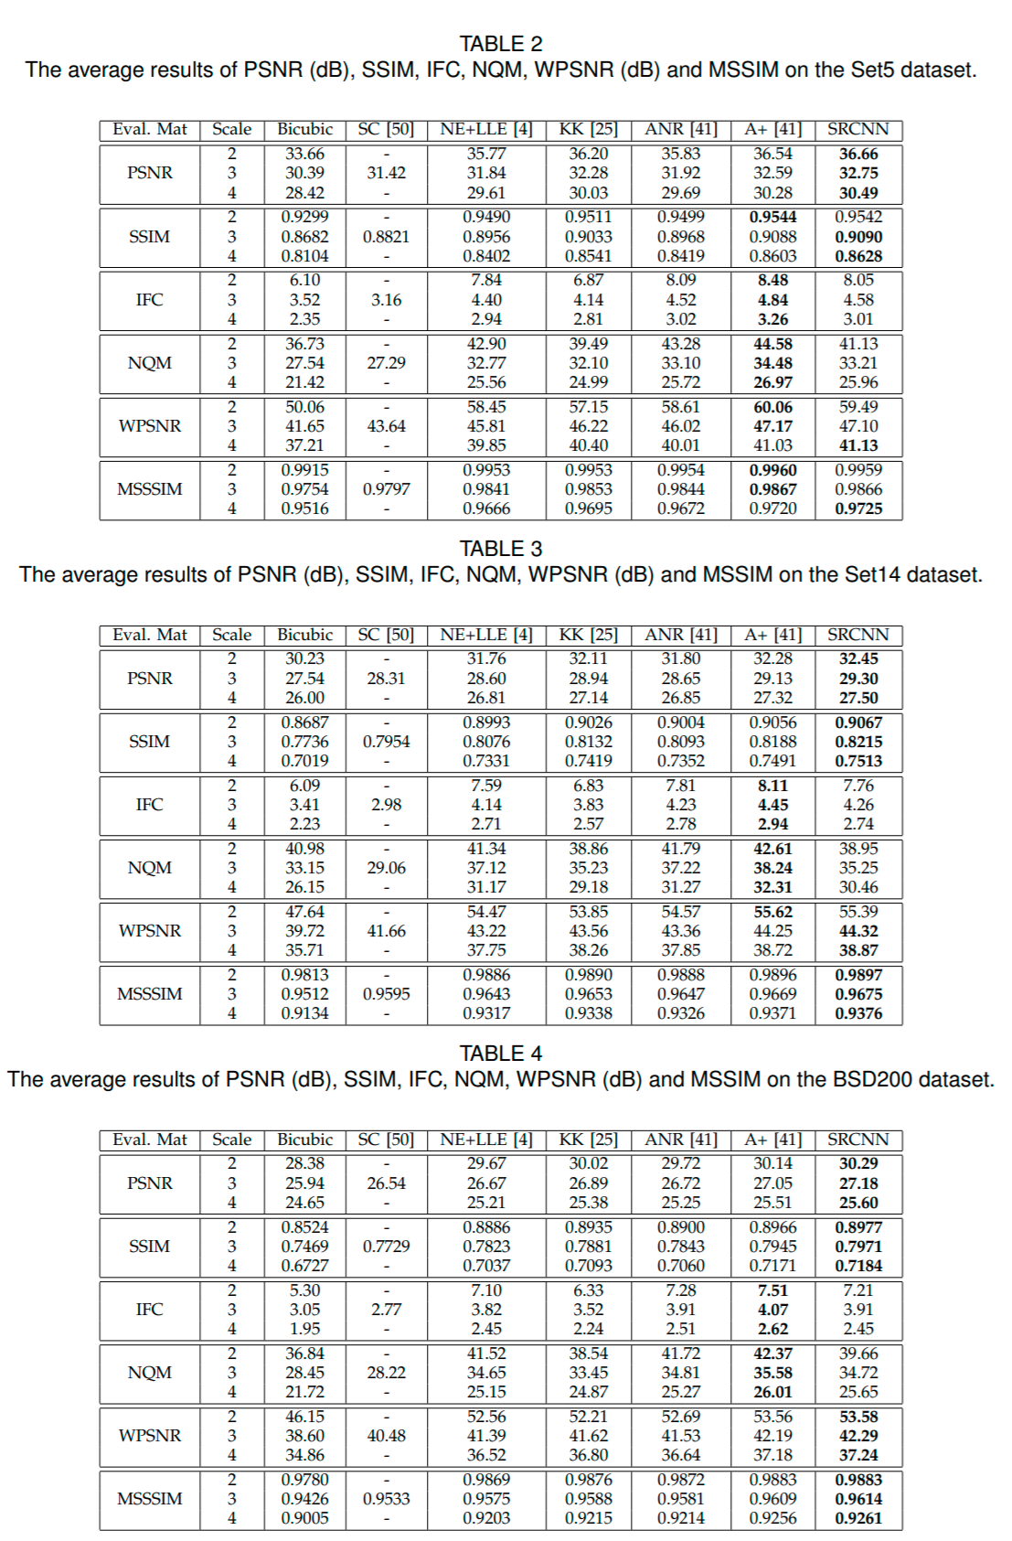

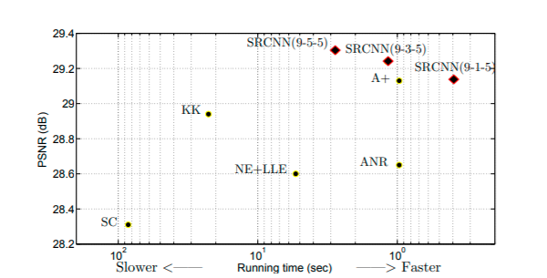

Adjusted anchored neighbor regression (A+) generally has better IFC, NQM and WPSNR performances while Convoluted Neural Network (SRCNN) excels in other criteria. SRCNN is significantly faster than A+ while keeping the same PSNR performance. Moreover, convoluted neural networks are more flexible in structure and there are many new modifications to realize its performance potential[8]. Thus, SRCNN is recommended for Super Resolution implementations.

IV. Conclusion

Among example-based Super Resolution implementations, SRCNNs exhibit best overall score and speed performance. It is expected that they will become mainstream methods in this field.

An interesting aspect of the comparison is the effect of streamlining. SRCNN incorporates elements of Sparse Coding and improved on it by being able to optimize all of the layers and as a whole. The integration into a system in many situations means oppoturnity to improve performance and successful engineering requires systematic and holistic perspective.

1. [Chao Dong, Chen Change Loy, Kaiming He, Xiaoou Tang: Image Super-Resolution Using Deep Convolutional Networks. IEEE Transactions on Pattern Analysis and Machine Intelligence ( Volume: 38 , Issue: 2 , Feb. 1 2016)](https://arxiv.org/abs/1501.00092)
2. [Yang, J., Wright, J., Huang, T.S., Ma, Y.: Image super-resolution via sparse representation. IEEE Transactions on Image Processing 19(11), 2861–2873 (2010)](https://www.researchgate.net/publication/224138603_Image_Super-Resolution_Via_Sparse_Representation)
3. [Chang, H., Yeung, D.Y., Xiong, Y.: Super-resolution through neighbor embedding. In: IEEE Conference on Computer Vision and Pattern Recognition (2004)](https://www.researchgate.net/publication/4082219_Super-resolution_through_neighbor_embedding)
4. [Timofte, R., De Smet, V., Van Gool, L.: Anchored neighborhood regression for fast example-based super-resolution. In: IEEE International Conference on Computer Vision. pp. 1920–1927 (2013)](https://www.cv-foundation.org/openaccess/content_iccv_2013/papers/Timofte_Anchored_Neighborhood_Regression_2013_ICCV_paper.pdf)
5. [Timofte, R., De Smet, V., Van Gool, L.: A+: Adjusted anchored neighborhood regression for fast super-resolution. In: IEEE Asian Conference on Computer Vision (2014)](http://www.vision.ee.ethz.ch/~timofter/ACCV2014_ID820_SUPPLEMENTARY/)
6. [Kim, K.I., Kwon, Y.: Single-image super-resolution using sparse regression and natural image prior. IEEE Transactions on Pattern Analysis and Machine Intelligence 32(6), 1127–1133 (2010)](https://ieeexplore.ieee.org/document/5396341)
7. [Yang, C.Y., Ma, C., Yang, M.H.: Single-image super-resolution: A benchmark. In: European Conference on Computer Vision, pp. 372–386 (2014)](https://www.researchgate.net/publication/278693824_Single-Image_Super-Resolution_A_Benchmark)
8. [Kwok-Wai Hung, Zhikai Zhang, Jianmin Jiang: Real-Time Image Super-Resolution Using Recursive Depthwise Separable Convolution Network. IEEE Access Vol.7, pp. 99804 – 99816 (2019)](https://ieeexplore.ieee.org/document/8764333)